Accounting midterm

Introduction: All equations in this paper has been written by the participants using LaTeX.

**Question 1:**

In progress on excel file in folder.

**Question 2: A three-period consumption-savings model**

1. **Derive the intertemporal budget constraint.**

To start off, we write out the functions for savings in each period:

Continue to expand the savings equation in period 2 to obtain:

Further, we have that the consumption in the third period is given by the equation:

Now that we have already full expanded the equation for a2 we can simply rewrite the the RHS to get the equality:

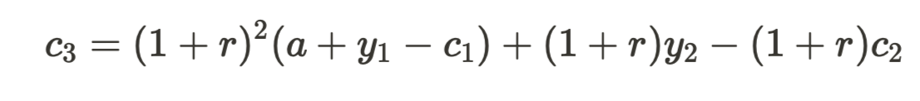

What remains to do to arrive at the intertemporal budget constraint is to rearrange this equation. We do so by moving all the consumption parameters to the LHS and all the income and inheritance parameters to the RHS. This leads to the equation:



Lastly, we divide both sides by (1+r)2 to get to the intertemporal budget constraint:

1. **Derive the Euler equations.**

In this exercise we are given the utility U. To find the Euler equations we have to first have to set up a Lagrangian for this exercise.



Where the u’s are a partition of the U utility function. Defined as:

Continuing, we use the First-order condition, which derivates the function with respect to c1, c2, and c3 and equates them to zero. This gives us the functions: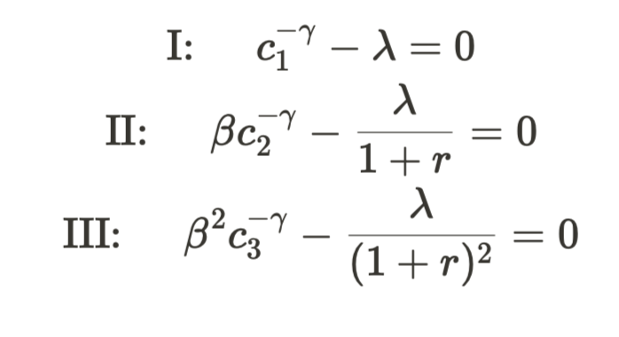

Where the roman numerals are just identifiers making it easier to make it more distinguishable which equation we are working on. Now that we have to FOCs, we can start by solving for lambda in equation I:

We can now use this in equation II and solve for consumption in period one to the power of negative gamma:

Now we have one of the two Euler equations corresponding to this problem. The second one can be found by the same process, but instead of substituting in equation II, we substitute the new value of lambda into equation III instead. This gives us the following solution:

And with this we conclude that the two Euler equations corresponding to this exercise is:

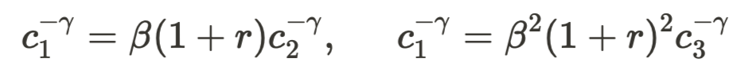

The two equations we have found describes how households trade the present against the future. Each equation corresponding to a different period in the future.

1. **Compute optimal consumption and savings for the first period.**

Have done the calculations on paper, just not made them in latex…